

**American International University- Bangladesh**

**CSC 3215: Web Technologies**

**CO2 and CO4 Evaluation**

**Finished Project Report**

**Spring/Summer/Fall 2020-2021**

**Project Title: Airline Ticket Reservation System**

**Section: H**

|  |  |
| --- | --- |
| Student Name | Student Id |
| Anik, Kayes Ahamed | **18-37254-1** |
| Hossain, Mohammed Shahriar | **18-37253-1** |
| Khan, Nishad | **18-37239-1** |

**Project Description:**

Airline Ticket Reservation System or flight reservation system is online web-based application designed to make flight ticket booking easier. A system which contains all the possible flights and route for a particular departure to destination location. User gets to choose from a variety of flights from multiple airlines if available for given route. The system enables the customer to do the things such as search for airline flights for two travel cities on a specified date, choose a flight based on the details, reservation of flight and cancellation of reservation. The system allows the airline passenger to search for flights that are available between the two travel cities, namely the “Departure city” and “Arrival city” for a particular departure and arrival dates. The system displays all the flight’s details such as flight no, name, price and duration of journey etc.

After search the system display list of available flights and allows customer to choose a particular flight. Then the system checks for the availability of seats on the flight. If the seats are available then the system allows the passenger to book a seat. Otherwise it asks the user to choose another flight. To book a flight the system asks the customer to enter his details such as name, address, city, state, credit card number and contact number. Then it checks the validity of card and book the flight and update the airline database and user database.

**Project Folder Structure:**

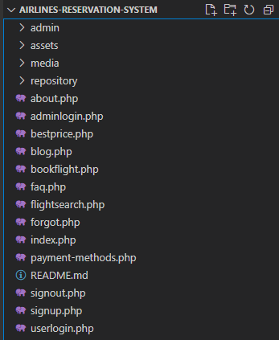

Fig 01: Main folder structure

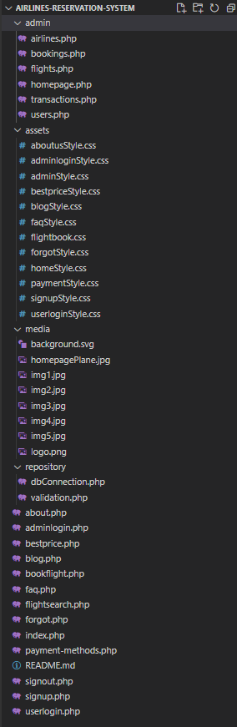

Fig 01: Detailed folder structure

**Core Modules of the Project:**

*Here, add THREE of your CORE modules’ source code with appropriate filename as heading. (Use either* consolas or courier new *font for source code)*

*For example:*

***index.php***

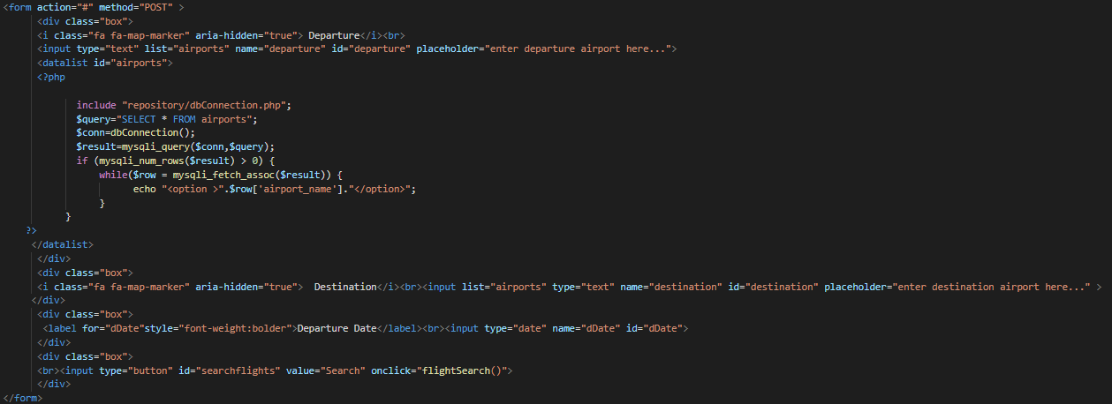

Figure 01: Live search of airports

***flightsearch.php***

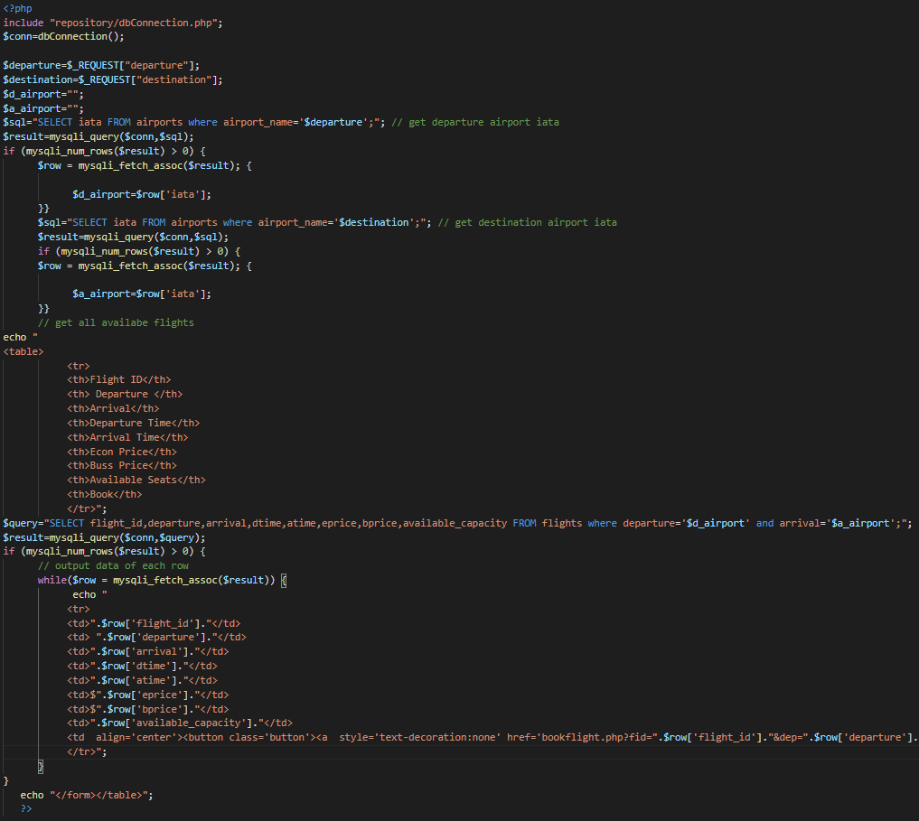

Figure 01: search of flights

***bookings.php***

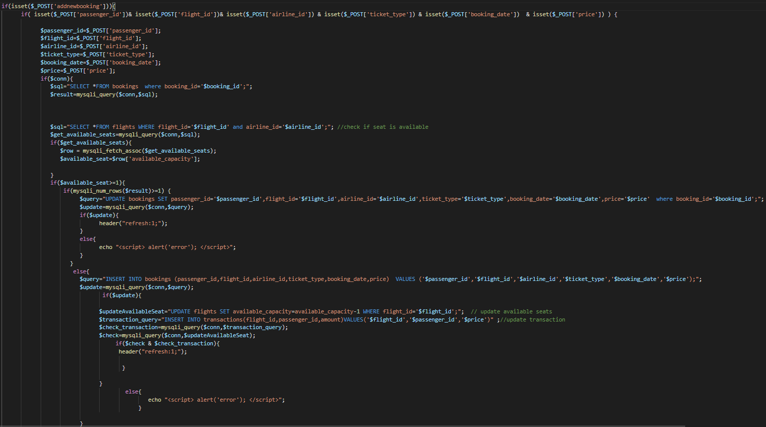

Figure 03: book new flight